Version Control System (VCS)

Definition
# Source: AI Source: Provided by: [Data Path: Persons Table -> ID Column: 1, Name_En Column: Motasem Essam] -> From: [ChatGPT] on [2/15/2026]
A Version Control System (VCS) is a tool that tracks changes to files over time, so you can:
- 🧾 See who changed what and when
- 🔁 Revert to earlier versions
- 🤝 Collaborate with others without overwriting each other’s work

🧠 In Simple Terms:
# Source: AI Source: Provided by: [Data Path: Persons Table -> ID Column: 1, Name_En Column: Motasem Essam] -> From: [ChatGPT] on [2/15/2026]
It's like a "time machine" for your code or documents.
You can go back to any point in time, compare changes, or undo mistakes.

✅ Why Use a Version Control System?
# Source: AI Source: Provided by: [Data Path: Persons Table -> ID Column: 1, Name_En Column: Motasem Essam] -> From: [ChatGPT] on [2/15/2026]
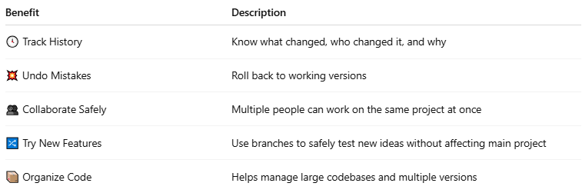

Benefit | Description
🕓 Track History | Know what changed, who changed it, and why
💥 Undo Mistakes | Roll back to working versions
👥 Collaborate Safely | Multiple people can work on the same project at once
🔀 Try New Features | Use branches to safely test new ideas without affecting main project
📦 Organize Code | Helps manage large codebases and multiple versions

🛠️ Types of Version Control Systems
# Source: AI Source: Provided by: [Data Path: Persons Table -> ID Column: 1, Name_En Column: Motasem Essam] -> From: [ChatGPT] on [2/15/2026]
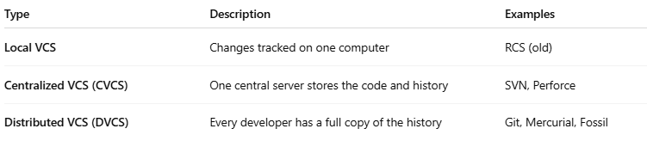

Type | Description | Examples
Local VCS | Changes tracked on one computer | RCS (old)
Centralized VCS (CVCS) | One central server stores the code and history | SVN, Perforce
Distributed VCS (DVCS) | Every developer has a full copy of the history | Git, Mercurial, Fossil

🔧 Popular Version Control Tools
# Source: AI Source: Provided by: [Data Path: Persons Table -> ID Column: 1, Name_En Column: Motasem Essam] -> From: [ChatGPT] on [2/15/2026]
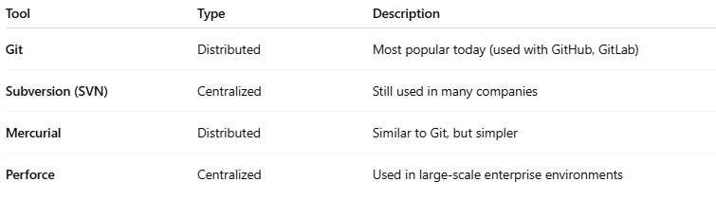

Tool | Type | Description
Git | Distributed | Most popular today (used with GitHub, GitLab)
Subversion (SVN) | Centralized | Still used in many companies
Mercurial | Distributed | Similar to Git, but simpler
Perforce | Centralized | Used in large-scale enterprise environments

🔁 Basic VCS Workflow (e.g., Git)
# Source: AI Source: Provided by: [Data Path: Persons Table -> ID Column: 1, Name_En Column: Motasem Essam] -> From: [ChatGPT] on [2/15/2026]
- Clone a project (download code + history)
- Edit code
- Commit changes with a message
- Push to share changes with others
- Pull to get the latest updates from teammates

🧪 Example (Git):
# Source: AI Source: Provided by: [Data Path: Persons Table -> ID Column: 1, Name_En Column: Motasem Essam] -> From: [ChatGPT] on [2/15/2026]
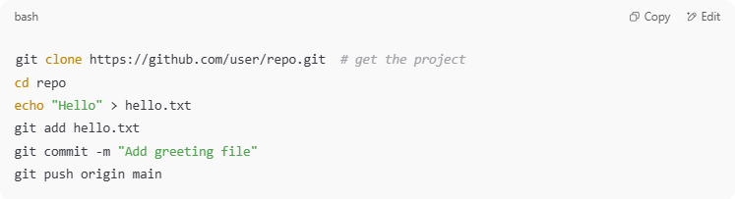

git clone https://github.com/user/repo.git # get the project
cd repo
echo "Hello" > hello.txt
git add hello.txt
git commit -m "Add greeting file"
git push origin main

🎯 Summary:
# Source: AI Source: Provided by: [Data Path: Persons Table -> ID Column: 1, Name_En Column: Motasem Essam] -> From: [ChatGPT] on [2/15/2026]
A Version Control System (VCS) is essential for:
- Building projects as a team
- Preventing loss of work
- Managing complex codebases

